



A scenario for the project

• The Disaster Management Department has a plan to develop a web application that use to report incidents occurred at different locations in Western Province. Examples of possible incidents are Natural Disasters, Road Side Accidents, Fires, and Electrical Breakdown & Leakages etc. Authorized personals from the Police stations, Grama Niladari, Post Office and assigned members from general public are issued login accounts, to report incidents.Incident reports manger has the total authority to approve the incident to be display in the public web. Incident report manager has a login account that has an authority to see all new incidents, approved incidents for the public display. Incident report manager has authority to change the threat level and effect of the incident to the general public. Once the incident report manager approves the incidents reported, they will be shown in a Map of Western Province. Create a web application using PHP or ASP.NET C# (with MySQL/Oracle/SQL Server database) to demonstrate the above scenario.

ABOUT

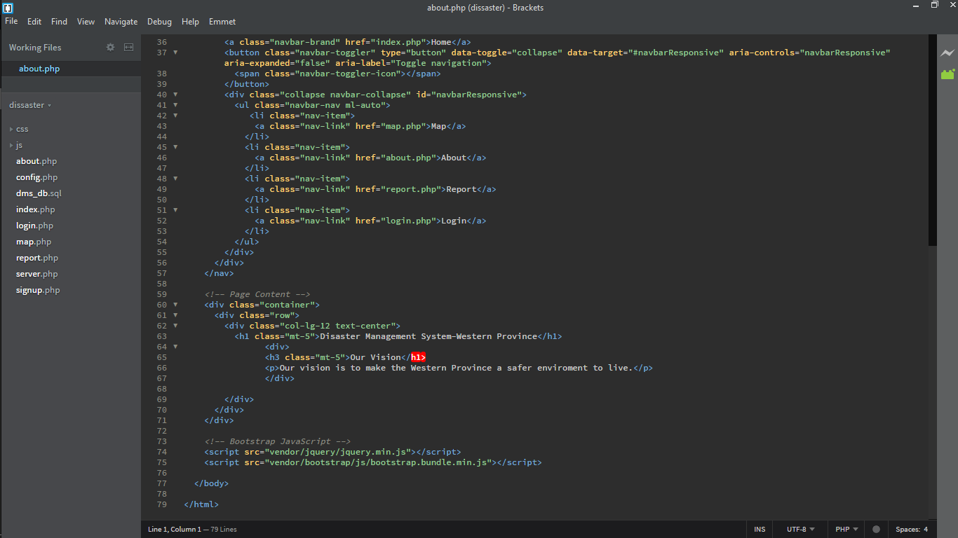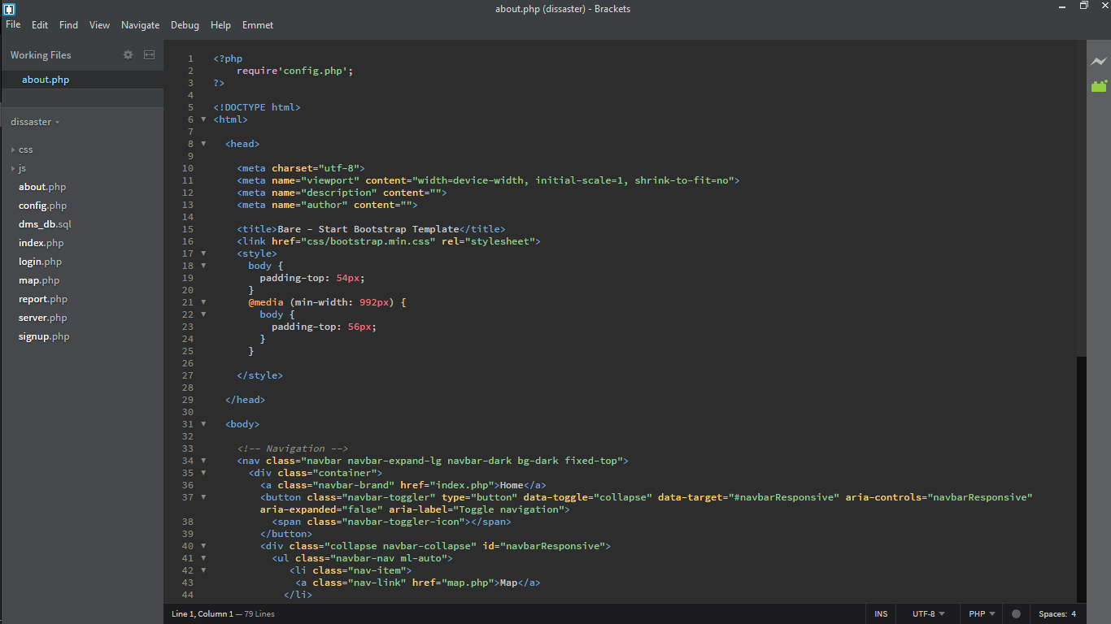

config.php

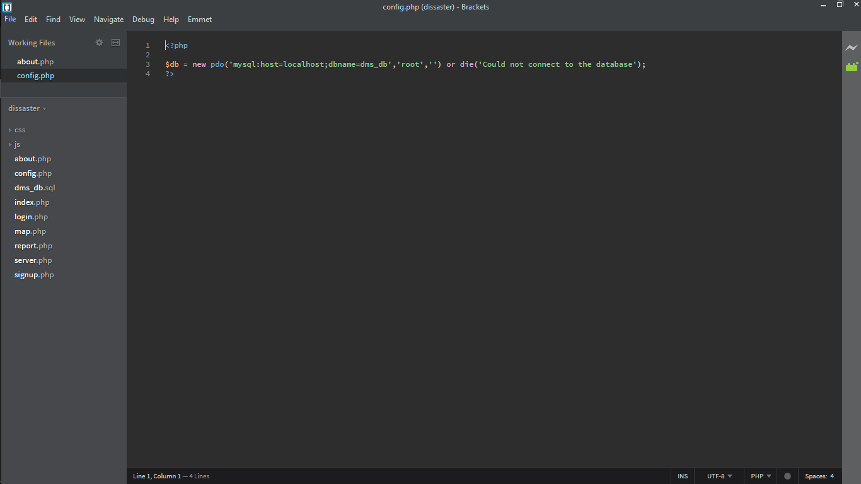

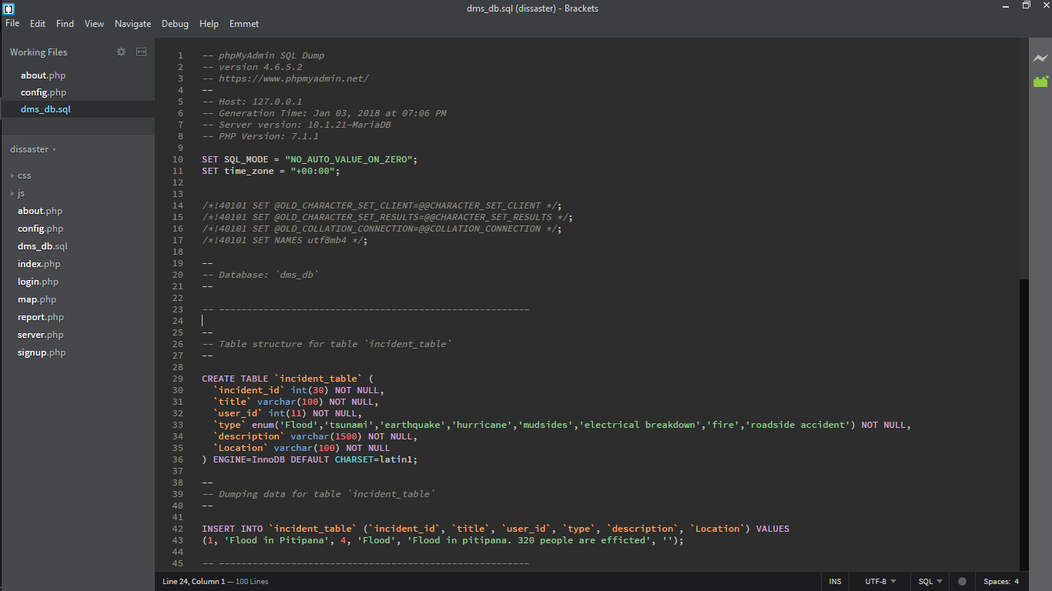dms_db.sql

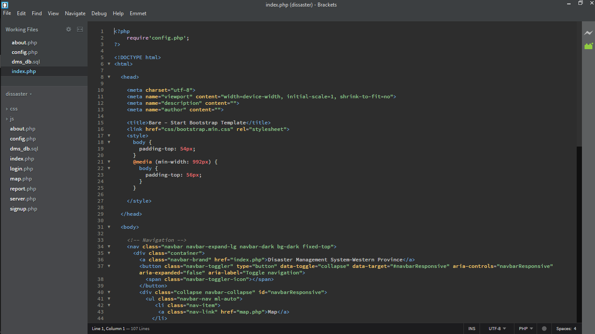index.php

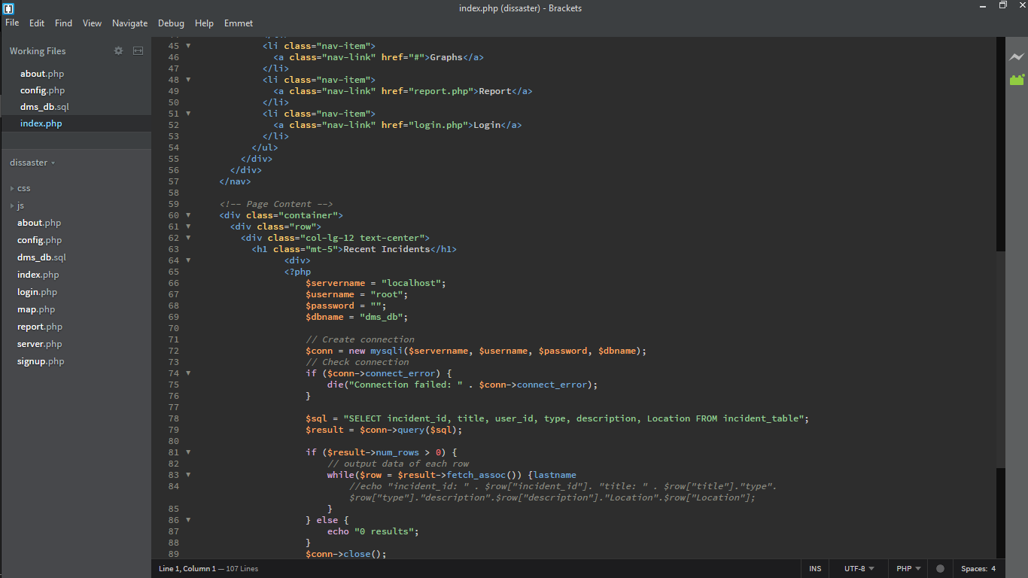

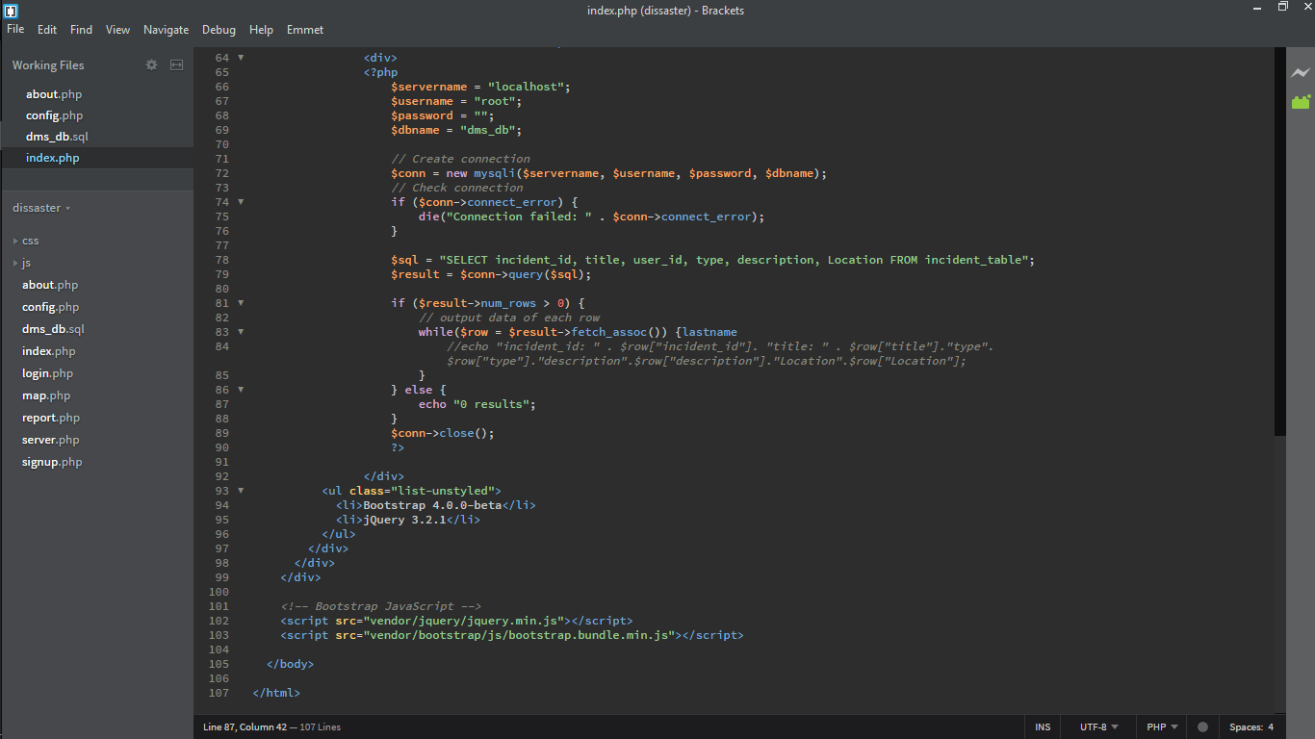

login.php

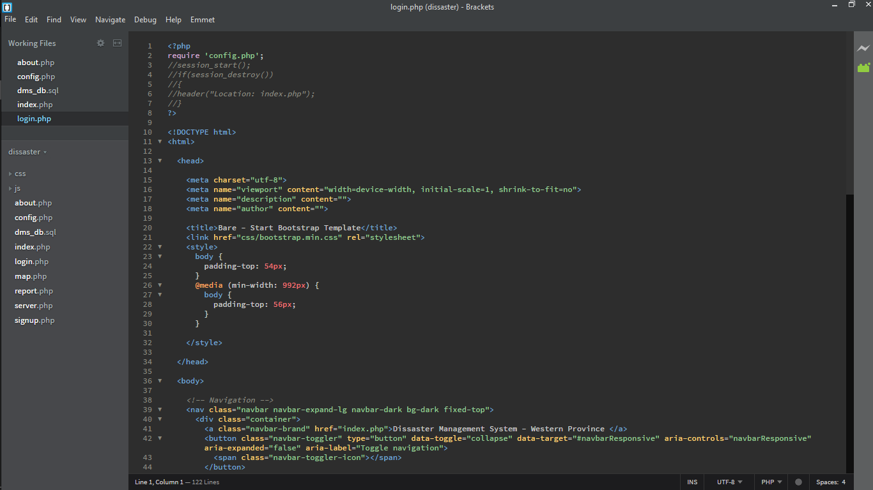

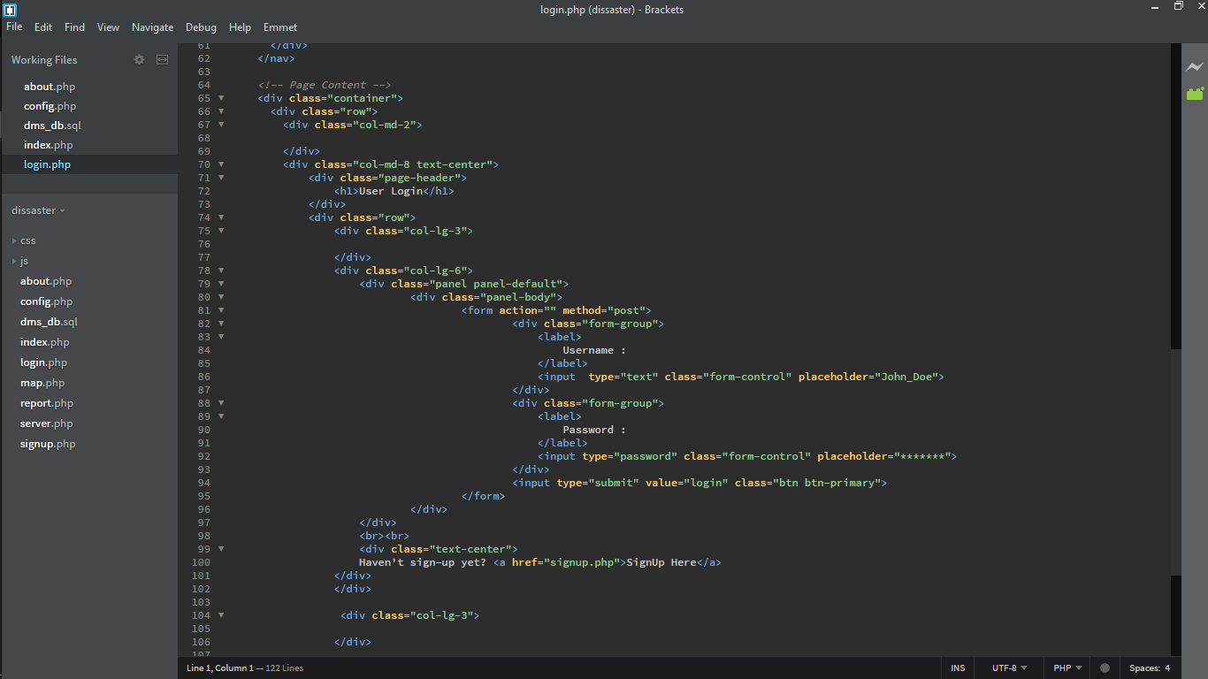

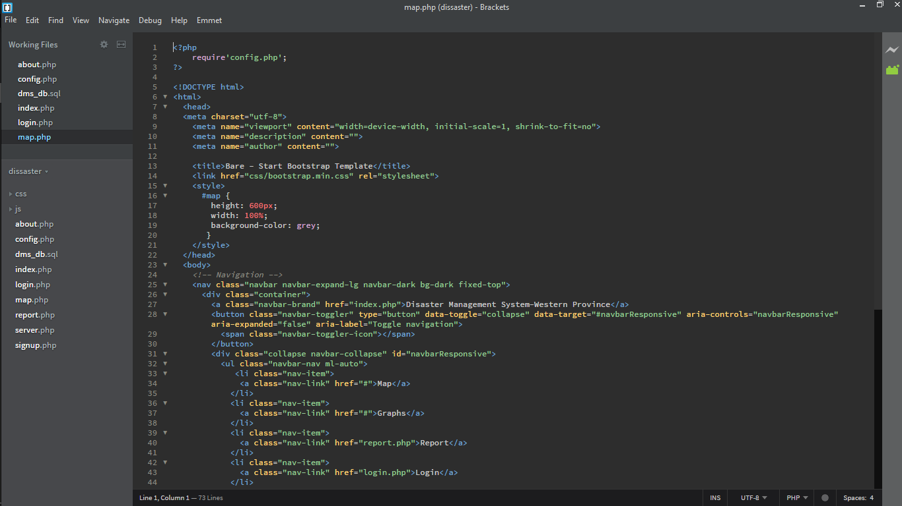map.php

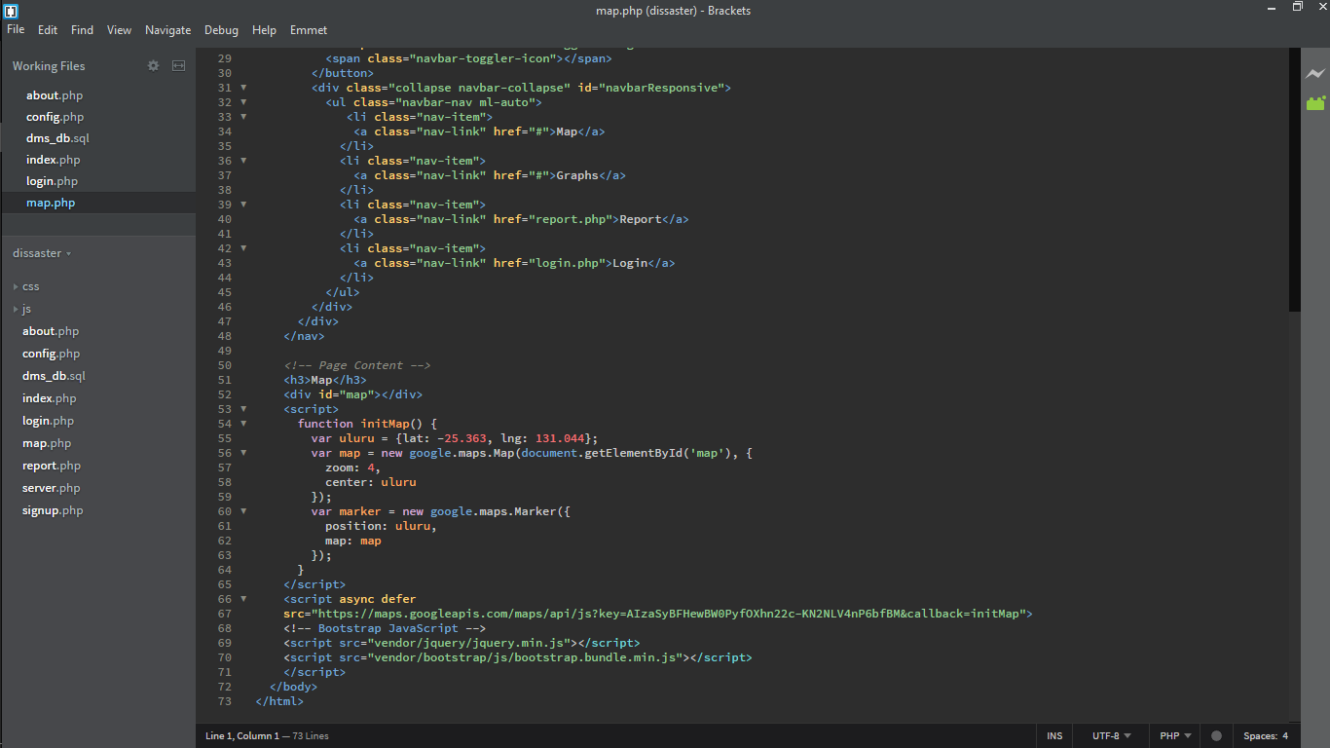

report.php

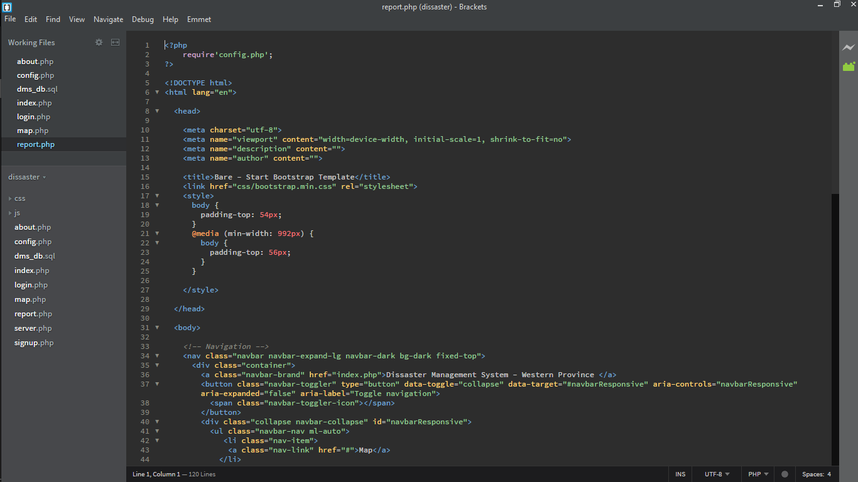

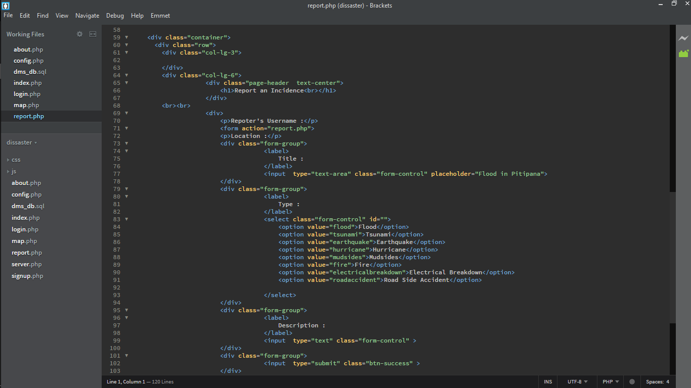

server.php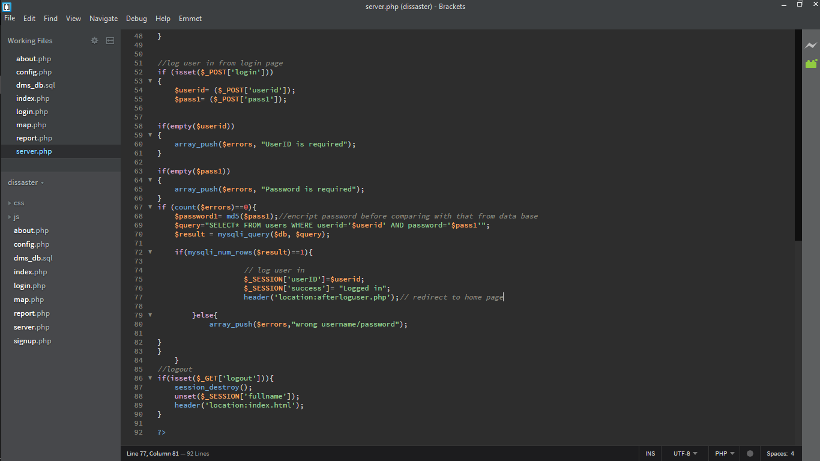

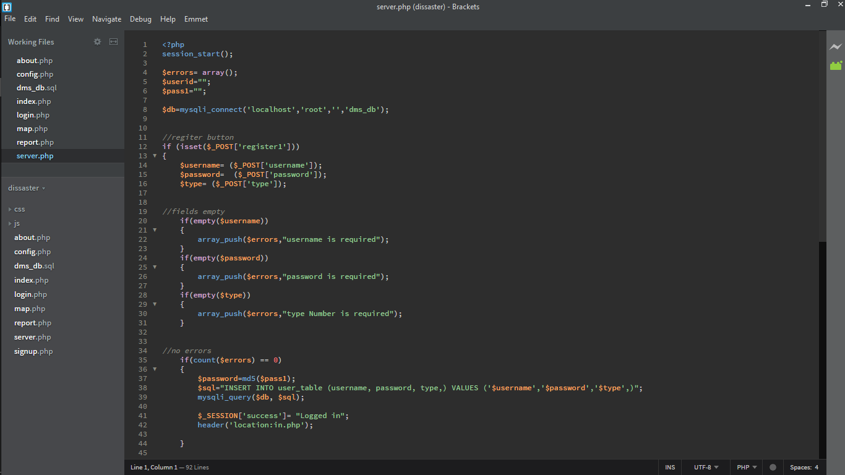

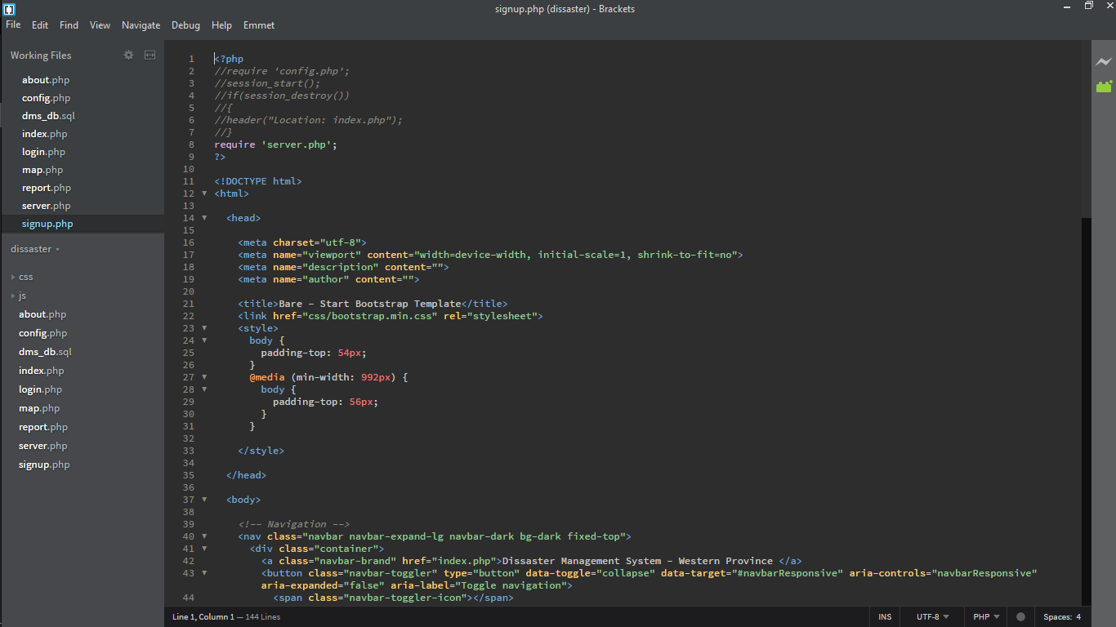signup.php

